**Trends of COVID-19 among school age children during the academic years 2020-2022 in the State of Qatar; a retrospective evaluation of the public health response using CDC indicators for COVID-19 community transmission**

1. Mohamed Ghaith Al-Kuwari

Sr. Consultant Preventive Medicine, Executive Director of Strategic Planning & Health Intelligence.

Author affiliation: Directorate of Strategy Planning and Health Intelligence, Primary Health Care Corporation, Doha, Qatar.

Email: [malkuwari@phcc.gov.qa](mailto:malkuwari@phcc.gov.qa)

Phone: +974-40270071

1. Azza Mustafa Mohammed

SME- Strategy Planning & Health Intelligence

Author affiliation: Directorate of Strategy Planning and Health Intelligence, Primary Health Care Corporation, Doha, Qatar.

Email: [azzmohammed@phcc.gov.qa](mailto:azzmohammed@phcc.gov.qa)

Phone: +974-40270056

1. Jazeel Abdulmajeed

Epidemiologist

Author affiliation: Directorate of Strategy Planning and Health Intelligence, Primary Health Care Corporation, Doha, Qatar.

Email: [jabdulmajeed@phcc.gov.qa](mailto:jabdulmajeed@phcc.gov.qa)

Phone: +974-31354453

1. Hamad Eid Al-Romaihi

Manager of Health Protection and Communicable Diseases

Author affiliation: Public Health Department, Ministry of Public Health, Doha, Qatar.

Email: [halromaihi@moph.gov.qa](mailto:halromaihi@moph.gov.qa)

Phone: +974-77322227

1. Maryam Al-Mass

Head of Screening Programs

Author affiliation: Preventative Health - Screening Programs, Primary Health Care Corporation, Doha, Qatar.

Email: [malmass@phcc.gov.qa](mailto:malmass@phcc.gov.qa)

Phone: +974-55572258

1. Shaikha Sami Abushaikha

Author affiliation: Department of Preventive Health. Primary Health Care Corporation, Doha, Qatar.

Email: [sabushaikha@phcc.gov.qa](mailto:sabushaikha@phcc.gov.qa)

Phone: +974-40270056

1. Soha Albyat

Head of Vaccination

Author affiliation: Public Health Department, Ministry of Public Health, Doha, Qatar.

Email: [salbayat@moph.gov.qa](mailto:salbayat@moph.gov.qa)

Phone: +974-44070975

1. Shazia Nadeem

Acting Head of Surveillance & Outbreak

Author affiliation: Public Health Department, Ministry of Public Health, Doha, Qatar.

Email: [snadeem@moph.gov.qa](mailto:snadeem@moph.gov.qa)

Phone: +974-44070196

1. Mujeeb Chettiyam Kandy

Head of Health Intelligence

Author affiliation: Directorate of Strategy Planning and Health Intelligence, Primary Health Care Corporation, Doha, Qatar.

Email: [mckandy@phcc.gov.qa](mailto:mckandy@phcc.gov.qa)

Phone: +974- 40271788

Corresponding author: Azza Mustafa Mohammed

Email: [azzmohammed@phcc.gov.qa](mailto:azzmohammed@phcc.gov.qa)

Telephone contact: +974-40270065

**Word count: 3,465 (main body) with 3 figures and one table**

**Abstract**

**Background:** the study examines evidence based on COVID-19 testing data and provides a comprehensive overview of infection patterns in school aged children (5-17 years old) compared to adults throughout two academic school years in the State of Qatar. We explore the use of the CDC’s COVID-19 community transmission indicators to identify data based alert points to guide schools’ attendance policies and public health response.

**Methods:** National SARS-CoV-2 electronic testing and laboratory database was used to identify all tests conducted between September 1st, 2020, and June 30th of 2022. The study subjects (<18 years old) were stratified into two age categories: (5-11) (12-17) to match the Primary and Preparatory/Secondary grade levels in Qatar, respectively. We estimated age group testing efforts, incidence rate, and positivity in comparison to adults. The former epidemiological measures were compared to the CDC’s thresholds for COVID-19 community transmission.

**Results:** A total of 5,063,405 and 6,130,531 tests were conducted during the school years (2020-2021) and (2021-2022), respectively. In (2020-2021), 89.6% of the tests were administered to adults and 13.7% tests were conducted on children in the second year. Trends in incidence and positivity percentage among all children age subgroups paralleled those of adults throughout the study period. Adolescents (12-17 years old) had higher incidence and positivity rates when compared to younger age group indicating possibility of driving higher levels of infections especially upon relaxation of social restrictions. The CDC measures of community transmission provided different information depending on the context of viral pathogenicity and population immunity.

**Conclusion:** This study shows that epidemiological surveillance is a crucial tool in understanding the dynamic of the COVID-19 pandemic especially among asymptomatic children that get tested through mass screening campaigns in the community and in school campuses.

**Background**

The novel coronavirus disease (COVID-19) has affected more than 29 million individuals worldwide [1]. In the State of Qatar, more than 400 thousand persons were infected with more than 600 deaths as of September of 2022 [2]. Qatar has taken many public health measures such as social distancing strategies to protect its population from COVID-19 disease and to reduce the incidence of new cases.

As part of the efforts to limit the spread of COVID-19 pandemic in Qatar, all schools were closed on March 10th of 2020[3]. Face-to-face classes were suspended, and students continued their learning through online learning platforms [3].

The Ministry of Education and Higher Education (MOEHE) in Qatar started phased opening of schools at the end of August,2020 with three stages back to school’s plan implemented on September 1st [4]. Through the academic year of 2020-2021, Qatar adopted a blended learning model that combines online classes with traditional classroom-based learning. The plan included risk mitigation measures such as enhanced hygiene efforts which include mandatory mask wearing and hand washing. Moreover, schools ensured reduced classrooms capacity and cohorting of students [4]. The first phase started with an on-campus attendance rate of 50% of students, while the other half attended online lessons. Students were split into groups with a maximum of 15 students per class to keep physical distance requirements and they alternated weekly. It was planned that students will move to 100% classroom attendance by the third phase. However, as cases started to increase in the community, schools moved to 30% attendance rate by March of 2021, and all students were attending only online classes by April of 2021.

During the next academic year of 2021-2022, schools adopted distance-learning mode at the beginning but quickly moved to a 100% face to face attendance. As COVID-19 cases started to rise again due to the Omicron variant, The Ministry decided to extend the winter holidays and school attendance was suspended for all students in public and private schools during the month of January 2022. By February, students were allowed back to schools at 100% capacity as long as they provide a weekly pledge form signed by the parent as evidence of negative rapid antigen test performed at home and within 48 hours of entering the school.

Studies conducted in the earlier months of the pandemic indicated that children in general have lower COVID-19 incidence rates [5]. A systematic review reported that children and young adults have lower odds (43%) of contracting secondary COVID-19 infection when compared to adults suggesting that they might play a smaller role in onward transmission [6,7]. Moreover, infection trends in multiple countries suggest that school-based transmission is not more frequent than transmission in non-educational settings [7,8,9]. On the other hand, there is evidence showing that the incidence rates in children and young adults are likely to be underestimated when compared to adults [10]. In most countries around the world testing prioritized symptomatic individuals [8]. The evidence used to support the theory of decreased COVID-19 burden in children might be confounded by testing bias as it is dependent on symptoms-based testing [11]. Children are less likely to be tested as the majority experience milder illness with less severe outcomes [10,12,13]. Besides, countries such as Israel and the United States reported significant school clusters of the disease [14].

Despite the ongoing debate about the contradictory evidence when it comes to schools opening and return to classroom education, there is no controversy that schools are very important community assets as they allow children to acquire skills and competencies in a supportive and safe environment. In addition, schools provide an opportunity to introduce programs to improve educational, social, behavioral and health related outcomes [15]. So, it is very important to carefully evaluate the risk of opening schools versus the possible negative impacts on children due to prolonged closure of schools [5,16,17].

There is a gap in our knowledge regarding the potential for schools to fuel the spread of SARS-CoV-2 in the State of Qatar. Hence, it is very important that decision makers have evidence to evaluate the risk of infection to students, school staff, and the surrounding community after opening of schools. We examined children’s, <18 years old, testing data during two consecutive academic years to understand the testing patterns and estimate the disease’s incidence and percentage of positive SARS-CoV-2 during the during study periods, school holidays, and major COVID-19 waves in comparison to adults. in addition, we explored the use of the CDC indicators for community transmission namely: population incidence, percentage of positive SARS-CoV-2, and the possibility of using them to identify data based alert points to guide escalations in the schools’ attendance policies [15,17], see supplementary Table 1.

**Materials and methods**

The State of Qatar is a peninsula on the western coast of the Arabian Gulf with a population of around 2.8 million. Around 10.5% of the total population are Qataris, while the rest are expats from more than 90 different nationalities [18]. National SARS-CoV-2 electronic testing and laboratory database was used to identify all tests conducted between September 1st, 2020, and June 30th of 2022. Demographic characteristics were extracted from the anonymized electronic medical records and no identifying information was collected. Rapid antigen testing (RAT) started in December 2021 (21st week of 2021-2022 academic year). In Qatar, all the laboratory COVID-19 testing is centralized and is conducted at Hamad Medical Corporation’s (HMC) central laboratory. This study was conducted in compliance with the Declaration of Helsinki and was approved by the Institutional Review Board (IRB) of the Primary Health Care Corporation (PHCC) with reference number PHCC/DCR/2020/11/134. The requirement for legal guardian and/or patient informed consent was waived by the IRB.

Data Analysis

The study subjects (<18 years old) were stratified into two age categories: (5-11) (12-17) to match the Primary and Preparatory/Secondary grade levels in Qatar, respectively. We estimated age group testing efforts, incidence rate, and positivity in comparison to adults (≥18 years old) during the two separate academic years. All the former epidemiological measures were expressed as number of cases per 100,000 population. We referred to the first school year as (2020-2021) or Y1 interchangeably, and we did the same for the second school year. Positivity rate was defined as the number of positive COVID-19 infections (identified by RT-PCR, or RAT) over the total number of all tested individuals. The one-way analysis of variance test (ANOVA) was used to determine the statistically significant differences between different age categories in the testing effort, incidence, and positivity rates. 7-days moving average was calculated to flatten anticipated variation in daily case numbers and tests’ positivity. Turkey’s test was used for post hoc analysis to determine the statistical significance of differences in group pairs means.

Additionally, we examined the differences among age groups during study periods (weeks 1-16, weeks 21-45), holidays (weeks 17-20 & 46-53, and during major COVID-19 waves namely Delta (weeks 23-38) and Omicron waves (weeks 17-24). During the academic year (2021-2022) the winter break was extended for an extra 4 weeks as a response to the Omicron wave.

For comparison, we used the CDC threshold for highest transmission of ≥200 new COVID-19 cases per 100,000 population in the last 7 days, and the percentage of positive RT-PCR tests ≥10% in the last 7 days. P value of ≤ 0.05 was considered the cut-off level for statistical significance. All statistical data analysis was conducted using STATA/MP 15.1.

**Results**

During the study period there was a total of 5,063,405 and 6,130,531 laboratory tests conducted during the school years (2020-2021) and (2021-2022), respectively (see Table 1). Most of the tests, 89.6% [n=4,537,604] in (2020-2021) were administered to adults, corresponding to a testing rate of 1.9 test per adult and 2.3 test per child. The same happened in the second year with 13.7% [n=840,634] tests conducted on population <18 years old, a testing rate of 3.6 tests per child and 2.3 tests per adult. RAT testing was used only during (2021-2022) to test 23.9% of adults, 31.2% of (12-17 years old), and 25.18% of (5-11 years old). Out of all tests conducted in Y1 and Y2 the overall test positivity was 5.8% and 8.1%, respectively.

|  |  |  |  |  |  |  |  |  |
| --- | --- | --- | --- | --- | --- | --- | --- | --- |
| **Table 1: Characteristics of persons tested and testing outcomes** | | | | | | | | |
|  | **Academic Year (2020-2021)**  **N (%)** | | |  | **Academic Year (2021-2022)**  **N (%)** | | |  |
| **Age group** | **(≥)18y** | **(12-17) y** | **(5-11) y** | **Total** | **(≥)18y** | **(12-17) y** | **(5-11) y** | **Total** |
| Gender |  |  |  |  |  |  |  |  |
| Female | 1,197,230 (26.38) | 98,124 (43.47) | 145,517 (48.5) | 1,440,871 (28.46) | 1,694,293 (32.03) | 156,611 (47.54) | 247,087 (48.33) | 2,097,991 (34.22) |
| Male | 3,340,374 (73.62) | 127,614 (56.53) | 154,546 (51.5) | 3,622,534 (71.54) | 3,595,604 (67.97) | 172,803 (52.46) | 264,133 (51.67) | 4,032,540 (67.78) |
| **Nationality** |  |  |  |  |  |  |  |  |
| Non-Qatari | 3,923,534 (86.47) | 129,716 (57.46) | 205,474 (68.48) | 4,258,724 (84.11) | 4,269,778 (80.72) | 177,930 (54.01) | 353,757 (69.20) | 4,801,465 (78.32) |
| Qatari | 61,4070 (13.53) | 96,022 (42.54) | 94,589 (31.52) | 804,681 (15.89) | 1,020,119 (19.28) | 151,484 (45.99) | 157,463 (30.8) | 1,329,066 (21.68) |
| **Test type** |  |  |  |  |  |  |  |  |
| PCR | 4,537,604 (100) | 225,738 (100) | 300,063 (100) | 5,063,405 (100) | 4,025,380 (76.1) | 226,620 (68.79) | 382,508 (74.82) | 4,634,508 (75.60) |
| RAT | 0 (0) | 0 (0) | 0 (0) | 0 (0) | 1,264,517 (23.9) | 102,794 (31.21) | 128,712 (25.18) | 1,496,023 (24.40) |
| **Test outcome** |  |  |  |  |  |  |  |  |
| COVID-19 Positive | 263,852 (5.81) | 13,599 (6.02) | 17,461 (5.82) | 294,912 (5.82) | 418,390 (7.91) | 32,454 (9.85) | 46,279 (9.05) | 497,123 (8.11) |
| COVID-19 Negative | 4,273,752 (94.19) | 212,139 (93.98) | 282,602 (94.18) | 4,768,493 (94.18) | 4,871,507 (90.15) | 296,960 (90.15) | 464,941 (90.95) | 5,633,408 (91.98) |
|  |  |  |  |  |  |  |  |  |
| **Total** | **4,537,604** | **225,738** | **300,063** | **5,063,405** | **5,289,897** | **329,414** | **511,220** | **6,130,531** |

Testing capacity

During Y1 -September1st ,2020- August 31st, 2021- the testing effort was directly associated with the age of the study subjects. The mean children to adults testing ratios per 100,000 population per week were: 0.79 (2403/3057) for (12-17 years old) and 0.64 (1978/3057) for (5-11 years old), p<0.05. When Qatar entered the Delta (B.1.617.2) variant wave towards the end of March 2021, more tests were conducted at a ratio of 0.88 (3763/4297) for (12-17 years old)/ adult and 0.68 (2904/4297) for (5-11 years old)/adult, p<0.000.

During the school holidays, the testing volume increased for children age groups with a mean difference of 275 tests per 100,000 persons between adults and (12-17 years old) & 510 tests per 100,000 persons between adults and (5-11 years old). So, although the children to adults testing ratios increased to 0.93 and 0.87 for (12-17) and (5-11), respectively, the difference between the age groups wasn’t statistically significant, p = 0.205. Figure 1 shows that the testing effort increased by the end of the schools’ summer vacation as Qatar’s residents (90% expats) were required to obtain a Covid-19 negative certificate by taking a PCR test after travel.

Looking at the consecutive academic year (2021-2022) we notice that there was a great increase in the testing effort in general. During the study period, the mean testing ratio for (12-17 years old) to adults per week per 100,000 population was 0.98 (3985/4075) compared to 1.1 (4409/4075) among the younger age group, p<0.000. This reflects the increase in testing requirements to attend schools especially among younger unvaccinated children (see figure 1, supplementary table 2). During the Omicron wave the testing effort was the highest in 12–17 years old with a mean of 7872 tests per 100,000 population compared to 6330 tests in the younger age group and 6723 in adults, P<0.05.

Incidence

During Y1 study period, the mean incidence rates per 100,000 population per week were: (116, 102, 83) in (adults, 2-17, 5-11, respectively, p<0.001 (see figure 2).

Looking at the difference among age groups in the Delta wave, the mean incidence rate associated directly with age group of the study subjects at (466, 424, 325) per 100,000 population among (adults, 12-17, and 5-11) p<0.05, respectively. The rate was the lowest during the school holidays at (76, 64, 54) in (adults, 2-17, 5-11, respectively. However, the difference wasn’t statistically significant, p>0.05.

By the end of January 2021, there was a rapid rise in incidence among all age groups exceeding the CDC threshold for covid-19 community transmission levels (see figure 2:A), and the officials responded by reimposing social restrictions to curb the increase at the beginning of February. Yet, the incidence continued to increase and more so among (12-17 years old) at 287 cases compared to 221 in adults and 201 in (5-11 years old), p<0.05. Schools moved to 30% on-campus attendance in March, and by the first week of April all on-campus attendance was suspended. During this period, the rate continued to increase in all age groups (642, 539, 412) in (adults, 12-17, and 5-11), respectively. After April, we can see clear decrease in the number of weekly cases. During this time, adults continued to have the highest rates at 321 cases per 100,000 population compared to 232 in (12-17) and 195 in (5-11) years old, but the difference between the groups wasn’t statistically significant.

In Y2 study period, incidence among all age groups remained clearly below the CDC threshold for highest covid-19 community transmission with mean rate of (79,139,170) cases per 100,000 (adults, 12-17, and 5-11) p<0.05, respectively. The levels increased tremendously during the Omicron wave. Children of both age categories experienced higher mean incidence rate at 2238 case in (12-17 years old) and 1804 in (5-11 years old). Adults had lower incidence at 1771 per 100,000 persons. Schools were operating 100% online after the winter break (week 21) until the end of January. After that schools moved to a 100% face to face attendance. In this time (see figure 2:B) we see a sharp decrease in the incidence until the end of the school year (43, 71,98) in (adults, 12-17, and 5-11), respectively, p<0.05.

Positivity

During study period of Year (2020-2021), tests conducted on adults resulted in positivity rate of 4% compared to 4.7% in (12-17) and 4.8% in (5-11), p>0.05. RT-PCR tests’ positivity steadily increased following the winter break reaching a mean level of (12.7%,16%, 16%) among (adults, 12-17, and 5-11) (see figure 3:A). This could be explained by the higher testing effort in adults during this period at 4856 tests per 100,000 persons compared to 3139 in (12-17), and 2543 in (5-11) as schools moved to 100% online attendance, p<0.05.

During 2021-2022, The positivity rates were the highest during the Omicron wave with mean positivity (26.7%, 26.5% among adults and children, respectively) p<0.001. The levels decreased tremendously in the following months with children (5-11) having the lowest mean positivity rate at 3.7% compared to 4.4% in (12-17 years old) and 4.7% in adults. This indicates the higher testing efforts among the younger children especially that they had the lowest vaccination rates when compared to the other age groups.

FIGURE 1: Number of weekly COVID-19 tests during school year (2020-2021) and (2021-2022) for different age groups. School holidays are marked in gray, and COVID-19 waves are marked in light pink. A 7-day running average was calculated.

FIGURE 2: Cases per 100,000 population during school year (2020-2021 [2:A]) and (2021-2022 [2:B]) for different age groups. School holidays are marked in gray, and COVID-19 waves are marked in light pink. A 7-day running average was calculated. The number of weekly cases was compared to the CDC indicator for risk of transmission in schools.

Figure 2:A

Figure 2:B

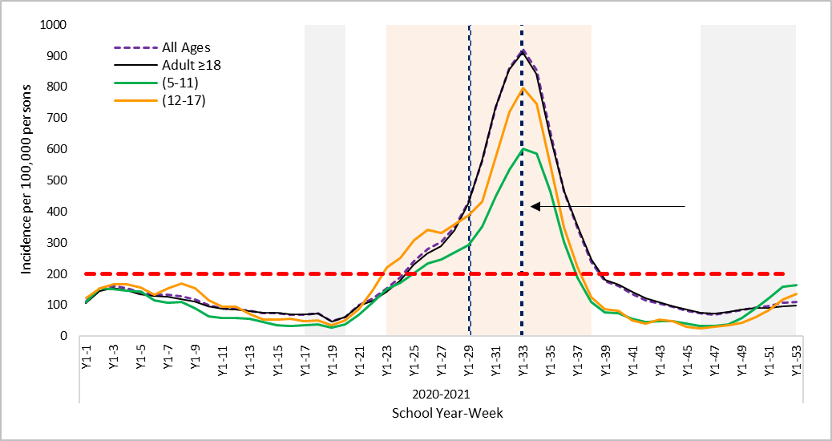

30% on-campus attendance

100% online school

CDC highest risk of transmission (>200 cases per 105  persons)

Qatar reimposes restrictions to curb the 2nd wave

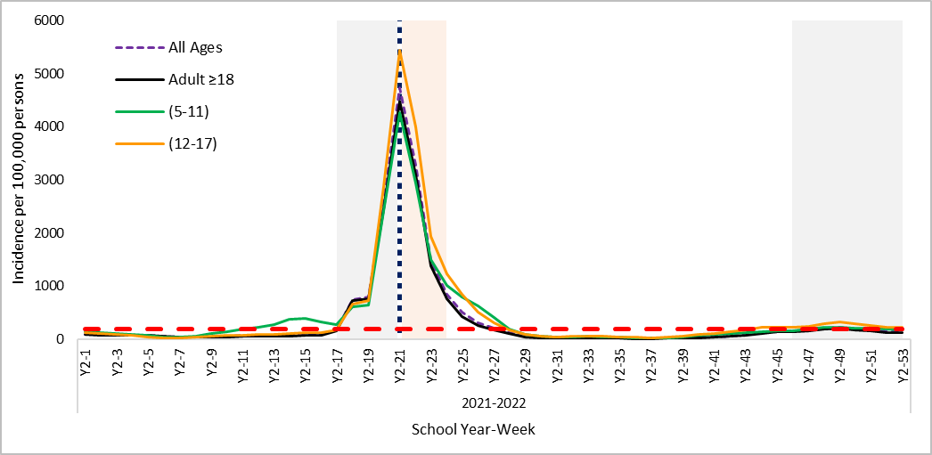

CDC highest risk of transmission (>200 cases per 105 persons)

100% online school

Figure 3:A

Figure 3:B

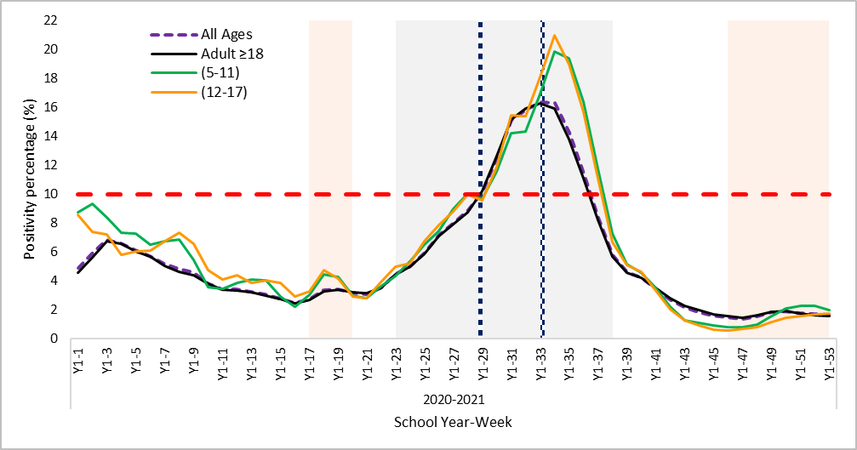

30% on-campus attendance

100% online school

CDC highest risk of transmission (>10% positive RT-PCR)

Qatar reimposes restrictions to curb the 2nd wave

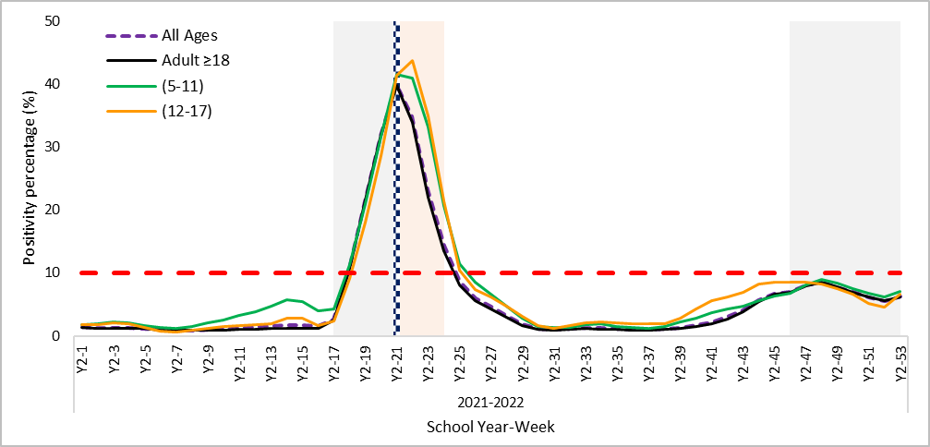

100% online school

CDC highest risk of transmission (>10% positive RT-PCR)

FIGURE 3: Weekly positivity rate for COVID-19 during school year (2020-2021 [2:A]) and (2021-2022 [2:B]) for different age groups. School holidays are marked in gray, and COVID-19 waves are marked in light pink. A 7-day running average was calculated. The number of weekly cases was compared to the CDC indicator for risk of transmission in schools.

**Discussion**

In this study, we examine available evidence based on COVID-19 testing data and provide a comprehensive overview of infection patterns in children of different age groups and adults throughout two academic school years in the State of Qatar. Understanding the infection dynamics in different age groups is crucial to inform public health policies regarding current and future openings of schools.

Overall, trends in incidence and positivity percentage among all children age subgroups paralleled those of adults throughout the study period. However, the study shows clear differences in the COVID-19 incidence in children (5-11 years old) attending primary schools, and adolescents (12-17 years old) attending preparatory and secondary schools with higher incidence and positivity rates in the later age group. Similar age-dependent infection trends were reported in USA [19,20], Italy [21], Spain [22], and other countries [23]. The observed difference between children and adolescents could also be explained by the fewer opportunities of exposure and testing among children less than 12 years old as during most of the first academic year children <12 years old were not allowed to enter shopping malls or closed spaces. The higher incidence and lower positivity in children (5-11 years old) following the Omicron wave is the direct result of the testing policy as all unvaccinated students had mandatory weekly rapid antigen test at home biasing their incidence rates, see supplementary table 2.

Alongside vaccination levels and layered prevention strategies, the Center for Disease Control and Prevention (CDC) recommends using two metrics for evaluating the level of community transmission: number of new COVID-19 cases per 100,000 persons and percentage of positive tests.

Using the CDC indicator for new number of cases as a benchmark, we notice rising infections among adolescents that preceded increases among adults by around 2 weeks (weeks 23-25) during the Delta wave. This might indicate that adolescents can drive higher levels of infections especially upon relaxation of social restrictions as Qatar, during the same period, started gradual lifting of social restrictions and increased the educational and workplace capacity. In addition, Qatar launched its national vaccination campaign in December of 2020 – around week 19- mainly targeting adults ≥18. In March, the public health officials prevented school staff from entering the campuses unless they started their vaccination or had a recent PCR test [24]. Therefore, the incidence in (12-17 years old) in February and March wasn’t affected by the vaccination of the school employees [22] and it remained relatively higher.

As a result, opening secondary/high schools is expected to contribute to the spread of COVID-19 [23]. Schools need to evaluate their individual risks based on their special environments and their ability to strictly adhere to layered prevention measures especially that by August of 2021, around 70% of eligible (12-17 years old) did receive at least one dose of the vaccine [25].

Moreover, in our study we attempted to use the CDC indicators to identify -retrospectively- data based alert points that can guide escalations in the schools’ attendance policies or even wide public health interventions. For example, during the academic year of 2020-2021, we can see that the community level of new COVID-19 cases started exceeding the threshold of highest level of transmission (>200 per 100,000) around week 25, and the percent of positive SARS-CoV-2 RT-PCR tests of (>10%) around week 29. Amid the surge in coronavirus cases, Qatar reimposed new social restrictions in February of 2021 to curb the second wave, and the schools continued to operate at 30% on campus capacity. Yet, it wasn’t until April 4th, 2021, that all schools switched to remote online learning for all students. Then, on April 9th, the public health administrators reimposed stricter preventive measures preventing social gatherings indoors as well as in parks and beaches. In addition, all leisure activities were suspended with closure of restaurants, cafes, cinemas, and libraries.

So, looking retrospectively at the whole context of the emergence of the novel Delta (B.1.617.2) variant in Qatar, the lower vaccination coverage at that time, the relatively fewer number of people with prior infection, and the fact that the rapid rise in new cases usually predicts an increase in the number of new hospitalizations or inpatient beds occupied by COVID-19 patients, we argue that the public health response should’ve happened between weeks (25-29) rather than April (week 33).

The Omicron wave in Qatar started right at the beginning of the schools’ winter holidays, and the public health officials responded by extending the break to the end of January 2022. In February, schools reopened with 100% class strength, layered prevention measures and mandatory weekly rapid antigen test at home for all students. Yet, the number of new cases in the community didn’t start to get below the CDC threshold until week 27, and the number of positive tests didn’t decline to the recommended test positivity until week 28 (around the beginning of March). Therefore, public health officials made decisions on relevant public health actions in the context of the lower viral pathogenicity of the Omicron variant [27], and higher population immunity in comparison to earlier times of the pandemic as around 86% of the population of Qatar received 2 doses of the COVID-19 vaccines by of December of 2021 [28].

Moreover, as we move to a different stage of the pandemic It’s important to include more comprehensive assessments including data on COVID-19 medical severity and healthcare system strain in addition to community transmission indicators to make more informative public health recommendations.

**Strengths and limitations**

The main strength of this study is that it’s a large population-based study of COVID-19 infection among children of different age groups and adults in two consecutive academic years. Also, we combined three epidemiological measures to better characterize the COVID-19 pandemic effect on children during study time, holidays and major COVID-19 waves. Finally, this is the first study in Qatar to explore the use of the CDC COVID-19 community transmission indicators to help making dynamic decisions about community precautions and schools opening as local circumstances evolve throughout the pandemic.

Nevertheless, our study has some limitations. Firstly, the infection rates among children and adolescents during the first academic year (2020-2021) are probably underestimated as children and young adults had lower testing rates when compared to adults. in our study only 10%-14% of the total tests were conducted on children <18. Al-Kuwari, M.G. and colleagues reported that individuals less than 18 years of age constituted only 20.3% of all people tested for COVID-19 in Qatar [22]. Moreover, we can’t separate the effect of schools’ closure alone from the rest of the public health measures implemented in the community. In Qatar, schools closure usually happens in accordance with other broad pandemic control measures, so we might not be able to show which one affected the other [7]. Even the epidemiological differences between children and adults in study vs. holiday periods, we can’t assume that they happened mainly because of school closure or opening. They can be highly affected by the travel testing policy as Qatar has a unique demographic structure.

**Conclusion**

This study shows that epidemiological surveillance is a crucial tool in understanding the dynamic of the COVID-19 pandemic especially among asymptomatic children that get tested through mass screening campaigns in the community and in school campuses. The CDC indicators offer an evidence-based approach to guide recommendations and it provide tools for making decisions at schools as well as monitoring the impact of these decision. More prospective research is essential to evaluate the risk of COVID-19 in educational settings in Qatar, especially that we are moving to a different stage of the pandemic.

**Declarations**

**Authors' contributions:** MGA: worked on the conceptualization. MGA,AMM & JA:, worked on methodology and design. MGA & AMM: worked on the original draft writing and preparation. HA, SA & SN: participated through oversight and overall planning of data collection. JA, AMM,MK: conducted data collection, curation, and formal analysis of the study data . SSA, MA: worked on overall project administration and management. MGA, AMM & JA: conducted the critical review of the article and the final approval of the version to be published. All authors agree to be accountable for all aspects of the work.

**Ethics approval and consent to participate:** The study was approved by the Institutional Review Board (IRB) of the Primary Health Care Corporation (PHCC) with reference number PHCC/DCR/2020/11/134. and the requirement for informed consent was waived by the Ethics Committee of the PHCC. The research was conducted in accordance with the Declaration of Helsinki.

**Acknowledgements:** Not applicable

**Funding:** The authors have not declared a specific grant for this research from any funding agency in the public, commercial or not-for-profit sectors.

**Competing interests:** The authors report no conflicts of interest in this work. The authors have no affiliation with any organization with a direct or indirect financial interest in the subject matter discussed in the manuscript

**Data availability statement:** No additional data are available.

**Abbreviations**

**CDC:** Center for Disease Control and Prevention

**PHCC:** Primary Health Care Corporation

**COVID-19**: Corona Virus Disease 2019

**MOEHE:** Ministry of Education and Higher Education

**IRB:** Institutional Review Board

**References**

1. World Health Organization. (2020). WHO Coronavirus Disease (COVID-19) dashboard. Retrieved from: https://covid19.who.int/
2. Ministry of Public Health, Qatar (MOPH). (2020). COVID-19 home. Retrieved from: https://covid19.moph.gov.qa/EN/Pages/default.aspx
3. Ministry of Education and Higher Education (MOEHE). (2020). The Covid-19 Challenge. Retrieved from: <https://www.edu.gov.qa/en/Pages/Corona.aspx>
4. Ministry of Education and Higher Education (MOEHE). (2020). The general orientation of the ministry in the next educational stage for public and private schools. Retrieved from: https://www.edu.gov.qa/ar/mediacenter/Pages/MediaCenter/NewsDetails.aspx?itemid=194
5. Royal Society DELVE Initiative. (2020). Balancing the Risks of Pupils Returning to Schools. Retrieved from: https://rs-delve.github.io/reports/2020/07/24/balancing-the-risk-of-pupils-returning-to-schools.html#1-background
6. Russell M Viner, Oliver T Mytton, Chris Bonell, et al. (2020). Susceptibility to and transmission of COVID-19 amongst children and adolescents compared with adults: a systematic review and meta-analysis. medRxiv 2020.05.20.20108126. Retrieved from: <https://doi.org/10.1101/2020.05.20.20108126>
7. Macartney, K., Quinn, H. E., Pillsbury, A. J., Koirala, A., Deng, L., Winkler, N., Katelaris, A. L., O'Sullivan, M., Dalton, C., Wood, N., & NSW COVID-19 Schools Study Team. (2020). Transmission of SARS-CoV-2 in Australian educational settings: a prospective cohort study. The Lancet. Child & adolescent health, S2352-4642(20)30251-0. Advance online publication. Retrieved from: <https://doi.org/10.1016/S2352-4642(20)30251-0>
8. Yung, C. F., Kam, K. Q., Nadua, K. D., Chong, C. Y., Tan, N., Li, J., Lee, K. P., Chan, Y. H., Thoon, K. C., & Ng, K. C. (2021). Novel Coronavirus 2019 Transmission Risk in Educational Settings. Clinical infectious diseases : an official publication of the Infectious Diseases Society of America, 72(6), 1055–1058. <https://doi.org/10.1093/cid/ciaa794>
9. Ismail, S. A., Saliba, V., Lopez Bernal, J., Ramsay, M. E., & Ladhani, S. N. (2021). SARS-CoV-2 infection and transmission in educational settings: a prospective, cross-sectional analysis of infection clusters and outbreaks in England. The Lancet. Infectious diseases, 21(3), 344–353. <https://doi.org/10.1016/S1473-3099(20)30882-3>
10. Leidman E, Duca LM, Omura JD, Proia K, Stephens JW, Sauber-Schatz EK. COVID-19 Trends Among Persons Aged 0–24 Years — United States, March 1–December 12, 2020. MMWR Morb Mortal Wkly Rep 2021;70:88–94. DOI: http://dx.doi.org/10.15585/mmwr.mm7003e1external icon
11. White, L. F., Murray, E. J., & Chakravarty, A. (2022). The role of schools in driving SARS-CoV-2 transmission: Not just an open-and-shut case. Cell reports. Medicine, 3(3), 100556. <https://doi.org/10.1016/j.xcrm.2022.100556>
12. CDC COVID-19 Response Team (2020). Coronavirus Disease 2019 in Children - United States, February 12-April 2, 2020. MMWR. Morbidity and mortality weekly report, 69(14), 422–426. Retrieved from: https://doi.org/10.15585/mmwr.mm6914e4
13. Fantini, M. P., Reno, C., Biserni, G. B., Savoia, E., & Lanari, M. (2020). COVID-19 and the re-opening of schools: a policy maker's dilemma. Italian journal of pediatrics, 46(1), 79. Retrieved from: <https://doi.org/10.1186/s13052-020-00844-1>
14. Bilinski, A., Salomon, J. A., Giardina, J., Ciaranello, A., & Fitzpatrick, M. C. (2021). Passing the Test: A model-based analysis of safe school-reopening strategies. medRxiv : the preprint server for health sciences, 2021.01.27.21250388. <https://doi.org/10.1101/2021.01.27.21250388>
15. CDC. (2020). Indicators for Dynamic School Decision-Making. Retrieved from: https://www.cdc.gov/coronavirus/2019-ncov/community/schools-childcare/indicators.html#thresholds
16. Viner, R. M., Bonell, C., Drake, L., Jourdan, D., Davies, N., Baltag, V., Jerrim, J., Proimos, J., & Darzi, A. (2020). Reopening schools during the COVID-19 pandemic: governments must balance the uncertainty and risks of reopening schools against the clear harms associated with prolonged closure. Archives of disease in childhood, archdischild-2020-319963. Advance online publication. Retrieved from: https://doi.org/10.1136/archdischild-2020-319963
17. CDC. Science Brief: Transmission of SARS-CoV-2 in K-12 Schools and Early Care and Education Programs – Updated. (2021). Retrieved from: <https://www.cdc.gov/coronavirus/2019-ncov/science/science-briefs/transmission_k_12_schools.html>
18. Al-Kuwari, M. G., Al Abdulla, S., Abdulla, M., Mohammed, A. M., Haj Bakri, A., Shaikhan, F., & Buhaddoud, H. (2021). Qualitative Focus Group Study Examining Perceptions of the Community's Important Health Issues, Health Care Needs and Perceived Barriers to Access Among Arabic Speaking Primary Care Clients in the State of Qatar. Journal of multidisciplinary healthcare, 14, 961–971. <https://doi.org/10.2147/JMDH.S288194>
19. Leeb, R. T., Price, S., Sliwa, S., Kimball, A., Szucs, L., Caruso, E., Godfred-Cato, S., & Lozier, M. (2020). COVID-19 Trends Among School-Aged Children - United States, March 1-September 19, 2020. MMWR. Morbidity and mortality weekly report, 69(39), 1410–1415. <https://doi.org/10.15585/mmwr.mm6939e2>
20. CDC. Operational Strategy for K-12 Schools through Phased Prevention. (2021). Retrieved from: <https://www.cdc.gov/coronavirus/2019-ncov/community/schools-childcare/operation-strategy.html#previous>
21. Buonsenso, D., De Rose, C., Moroni, R., & Valentini, P. (2021). SARS-CoV-2 Infections in Italian Schools: Preliminary Findings After 1 Month of School Opening During the Second Wave of the Pandemic. Frontiers in pediatrics, 8, 615894. <https://doi.org/10.3389/fped.2020.615894>
22. Perramon, A., Soriano-Arandes, A., Pino, D., Lazcano, U., Andrés, C., Català, M., Gatell, A., Carulla, M., Canadell, D., Ricós, G., Riera-Bosch, M. T., Burgaya, S., Salvadó, O., Cantero, J., Vilà, M., Poblet, M., Sánchez, A., Ristol, A. M., Serrano, P., Antón, A., … Soler-Palacin, P. (2021). Schools as a Framework for COVID-19 Epidemiological Surveillance of Children in Catalonia, Spain: A Population-Based Study. Frontiers in pediatrics, 9, 754744. <https://doi.org/10.3389/fped.2021.754744>
23. Goldstein, E., Lipsitch, M., & Cevik, M. (2021). On the Effect of Age on the Transmission of SARS-CoV-2 in Households, Schools, and the Community. The Journal of infectious diseases, 223(3), 362–369. <https://doi.org/10.1093/infdis/jiaa691>
24. Hukoomi (Qatar e-Government). (2021). MOEHE: Preventing Employees from Entering Schools except on the Condition of Vaccination or Examination. Accessed 9.2022:

<https://hukoomi.gov.qa/en/news/moehe-preventing-employees-from-entering-schools-except-on-the-condition-of-vaccination-or-examination>

1. Ataullah, A. (2021). 70% students aged 12 to 17 receive COVID-19 vaccine. The Peninsula. Accessed 9.2022. <https://thepeninsulaqatar.com/article/19/08/2021/70-students-aged-12-to-17-receive-COVID-19-vaccine>
2. CDC. (2022). Science Brief: Indicators for Monitoring COVID-19 Community Levels and Making Public Health Recommendations. Accessed 9.2022.

<https://www.cdc.gov/coronavirus/2019-ncov/science/science-briefs/indicators-monitoring-community-levels.html>

1. Sigal A. (2022). Milder disease with Omicron: is it the virus or the pre-existing immunity?. Nature reviews. Immunology, 22(2), 69–71. <https://doi.org/10.1038/s41577-022-00678-4>
2. Ministry of Public Health, Qatar (MOPH). (2021). National Covid-19 Vaccination Program Data. Retrieved from: <https://covid19.moph.gov.qa/EN/Pages/Vaccination-Program-Data.aspx>